Crime Pattern Analysis and Predictive Modeling in Los Angeles

Philip Chan International Political Economy
and Development Fordham University New York City, US pchan16@fordham.edu
Frederic Bomba Mbida International Political Economy and Development
Fordham University New York City, US fb26@fordham.edu

Abstract: This paper attempts to predict the victim’s gender and demographics based on the other features within crime records from the Los Angeles Police Department. We attempt to make predictions using conventional data mining techniques such as: Decision Trees, Neural Networks, K-Means, Hierarchical Clustering, and Association Analysis. However, most of the techniques fail to generate useful information and predictions.
This study applies data mining techniques to over 100,000 crime records from the Los Angeles Police Department, examining temporal crime patterns, demographic trends of victims, spatial clustering, and association rule mining. Results indicate that the crime rate peaks at midday and evening, consistent with the routine activity theory. To address severe class imbalance in victim demographics, Random Forest classifiers combined with SMOTE were employed to predict victim racial descent variables. Additional techniques, such as K-means clustering, hierarchical clustering, geospatial mapping, and neural networks, were used to identify structural patterns. Findings highlight location concentrations, temporal crime cycles, and disparities across demographic groups, providing insights for policymaking.
Keywords: Crime, data mining, random forest, SMOTE, classification, association rule mining, victim demographic.
- Introduction
Urban crime analysis is a key application of data mining, enabling law enforcement agencies to transition from reactive to proactive strategies. Moreover, it informs public safety and policing strategies. (Bharati and Chaudhury, 2021).. Generally, large metropoles generate high volumes of datasets that can be mined to uncover temporal, spatial, and demographic patterns. This paper aims to utilize classification, clustering, association rule mining, and neural networks on crime data to identify the features most strongly associated with the victim’s race and sex, the type of weapon used, and the time of the crime. Unlike traditional criminological studies, which often rely on surveys or aggregate statistics, it examines the
relationships between variables and identifies how specific attributes are correlated with various demographic outcomes. For policymakers, such evidence-based insights are invaluable, because they help to understand temporal, spatial patterns in criminal behavior, create policies to target particular crimes, allocate resources efficiently, evaluate the reasons behind crime, and find solutions to prevent crimes, while grounding on interventions in criminological theories such as social disorganization theory (Sampson and Groves) and routine activity theory (Cohen and Felson). In other words, policymakers can make evidence-based decisions rather than relying on intuition.
The primary objective of this project is to utilize data mining techniques to identify hidden patterns in crime data. Specifically, patterns were analyzed by day, time of day, crime type, weapon type, and geographic location. In addition, these patterns were complemented with economic and political analysis to interpret and explain potential social or structural issues.
- Techniques
- Data Rebalancing
The dataset contains racial and gender categories with uneven representation. Some groups, such as Pacific Islanders or Asians, appear less frequently than others, leading to a class imbalance that biases toward the majority class. To mitigate this, Random Oversampling (ROS) and SMOTE (Synthetic Minority Oversampling Technique) were applied. Hence, the classifier will not always predict the most represented class.
- Tasks and packages
This project uses both descriptive (clustering and association analysis) and predictive (classification) tasks. Clustering and association analysis are employed to gain a deeper understanding of the data, enabling us to identify potential relationships between the variables. Classification is used to predict the victim's race and gender based on all other

features at the individual level. The results were then compared with real-world statistics on crime in Los Angeles to determine whether they are similar or different. If our results are comparable to real-life crime stats, then the model captures meaningful relationships with the data.
Python Scikit-learn was used for this project, supported by Pandas, Numpy, and Matplotlib for data preprocessing and visualization. Clustering, association analysis, and classification were employed. For the algorithms, decision trees were employed to identify key predictors, and a Random Forest was used to improve generalization by combining multiple trees. To evaluate the model's performance, multiple classification metrics were employed to ensure fairness and robustness, including accuracy (for the overall percentage of correct predictions), F1-Score (for imbalanced data), precision, and recall. These metrics were computed with respect to the minority
class to avoid bias.
- Background
Since 2020, numerous reports have been made of an increase in crime across the United States, particularly in hate crimes targeting minority groups. Reports from the Los Angeles Police Department indicate that in 2020, anti-Asian crime increased by 114%, consistent with national trends linking Covid-19 stigma to racialized victimization (Gover, Harper, and Langton). Similarly, in 2023, anti-Jewish crime increased by 91% to 242. At the same time, transgender hate crimes increased by 125% to 99.^{i}
As a result of an increase in crime in Los Angeles in 2024, California voters voted overwhelmingly for Proposition 36, which increased penalties for certain theft and drug offenses and mandated drug treatment after conviction. Simultaneously, voters recalled the District Attorney of Los Angeles County, George Gascon. Voters blamed him for the spike in crime in Los Angeles because he refused to prosecute juveniles as adults, prosecute certain misdemeanors, or file most sentencing enhancements. Also, he admitted in an interview that he doesn't know whether the 42,000 defendants that he failed to prosecute received any treatment. Officials were concerned that the defendants were getting the help they needed and could commit crimes after being released. As a result, city attorneys wanted Gascon to remove their cases from Gascon's purview.^{ii}
Finally, former Los Angeles County District Attorney Steve Cooley criticized George Gascon for the surge in crime because criminals “all know about Gascón and the soft policies. They all know that juveniles, even if they commit multiple murders, will never, ever be tried in adult court, even though they are age 16 or age 17. They know it, and they take advantage of it” (Lee and Khorrami). Based on the reaction of voters and government officials, it prompted us to investigate whether Gascon was to blame for the surge in crime in Los Angeles. While such narratives dominate public discourse, criminological research cautions against attributing crime fluctuations solely to prosecutorial discretion (Tonry).
This study, therefore, seeks to determine if a pattern exists with the reported crimes in Los Angeles. By utilizing data mining, this project examines whether crime trends follow predictable patterns, independent of political narratives.
Specifically, we determine whether we can predict the race and gender of crime victims based on the variables in the data and identify the features most closely associated with the victims’ race and sex.
- Related Works
In 2015, using crime data from Denver and Los Angeles, Tahani Almanie, Rsha Mirza, and Elizabeth Lor of the Department of Computer Science at the University of Colorado Boulder utilized the Apriori algorithm to identify interesting frequent patterns in criminal hotspots. They used a Decision Tree classifier and a Naïve Bayesian classifier to predict crime types (Almanie, Mirza, and Lor). They successfully identified crime patterns in Los Angeles and Denver based on location, day of the week, and time. However, many of the patterns that they found had low minsup (0.001 or 0.002). Their Naïve Bayes and Decision Tree models have an accuracy of 40%-50% but didn’t help generalize the data, meaning they can’t learn from their models.
Similarly, Christopher Dondanville, Xihui Zhang, and Ted E. Lee of the University of Memphis conducted a similar experiment but also failed to find interesting patterns or new information. They used Nearest Neighbor, Clustering, Association Analysis, Text Analysis, and Decision Trees to mine their data (Dondanville, Zhang, and Lee). They found correlations that were already known. They recognized the challenge of identifying patterns and valuable information without domain expertise and a background in criminology. For them, the dimensionality and features of the crime data made it very difficult to produce accurate predictions from the data. They only found simple correlations and no new information.
Also, Er. Navjot Kaur Sekhon and Ranjanpal Kaur of Chandigarh University utilized data mining techniques and algorithms to detect crime. They used KNN, Decision Tree, SVM, and XG Boost. Using these algorithms, they found that “Conventional methods are suitable only for small scale problems with low dimension. These methods, if applied to high dimensional problems may lead to errors and computational problems” (Sekhon and Kaur). This is similar to the works of other papers in which dimensionality prevents authors from finding useful information. They would use unconventional data mining to find patterns and useful information.
Finally, S. Yamuna and N. Sudha Bhuvaneswari of Dr.
G. R. Damodaran College of Science, Coimbatore, utilize data mining techniques to detect and prevent crimes. Like other papers, it is challenging to identify patterns because daily criminal activity generates large datasets. They use clustering algorithms (K-Means and DBSCAN) to examine the relationship between changes in crime and changes in the type of crime. For example, they found crime dropping, lower rates of violent crime (rape and murder), but an increase in sexual harassment (Yamuna and Bhuvaneswari, 2012). Unlike other papers, they suggest that data mining could be used to detect financial crime. They found patterns using only clustering, but not with any other algorithms.
Based on these papers, clustering is the most effective algorithm for identifying patterns compared to other algorithms.

Additionally, it is challenging to identify patterns and predict crimes from high-dimensional crime data.
- Statistical Analysis
Temporal Trends
Through Graph 1 below, it is shown that regardless of the victims' demographics, the time people experience crime mostly peaks at noon. After 12:00 pm, crime rates start to fluctuate and experience another peak around 5 pm. This aligns with common criminological findings that link crime to routine social activity patterns (Cohen and Felson, 1979). Crime starts decreasing from 12:00 am to 5:00 am. Crime is at its lowest at 5 am. After 5 am, crime rates begin to increase, peaking at 12 pm. Most crimes are committed at night and in the afternoon. Demographically, Hispanics/Latinos and White are mostly the victims of crime, followed by Blacks, Unknown, and Asians.
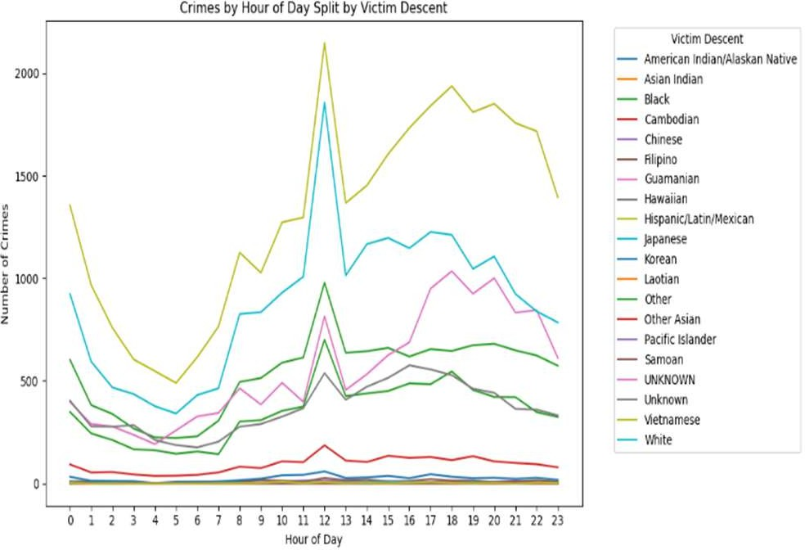
Graph 1: Victim Demographics Based on the Time of Day.
Based on Graph 2 below, it can be observed that during the winter season (January to April), crime rates begin to decrease. Most likely because when it is too cold, people tend to move less. It starts increasing in the spring (April to June), most likely due to the favorable weather and daylight saving time. It starts decreasing over the summer (June-September). It might be too hot for people to move. After September (fall), there is a fluctuation in crime until November. From November to December, crime rates typically peak. After December, crime rates decrease until April. In the fall, the weather is neither too cold nor too hot, which makes it more likely for crime to occur. Such variations are consistent with seasonal mobility theories in criminology.
Seasonal Variation
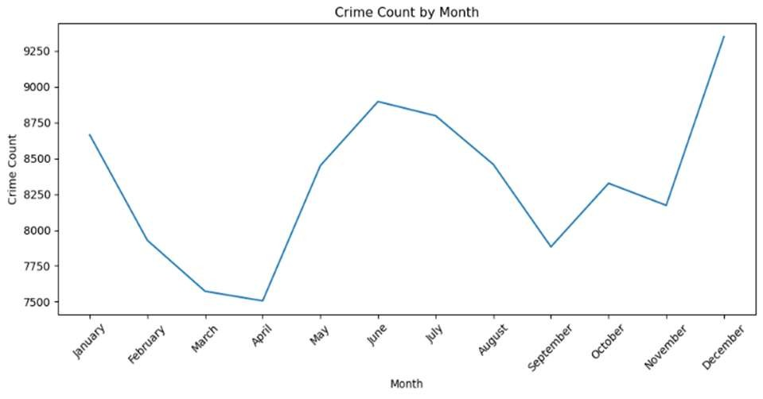
Graph 2: Crime Count by Month.
Based on the gender distribution data, most males are victims of crime compared to females. However, the balance between males and females is generally well-maintained. Crimes against females and males are most likely to occur in the afternoon and at night, compared to the morning and evening. In the morning, everyone is mostly at home sleeping. In the evening, many people are on the streets after leaving work. At night, it is very dark, making it a favorable time to commit a crime.
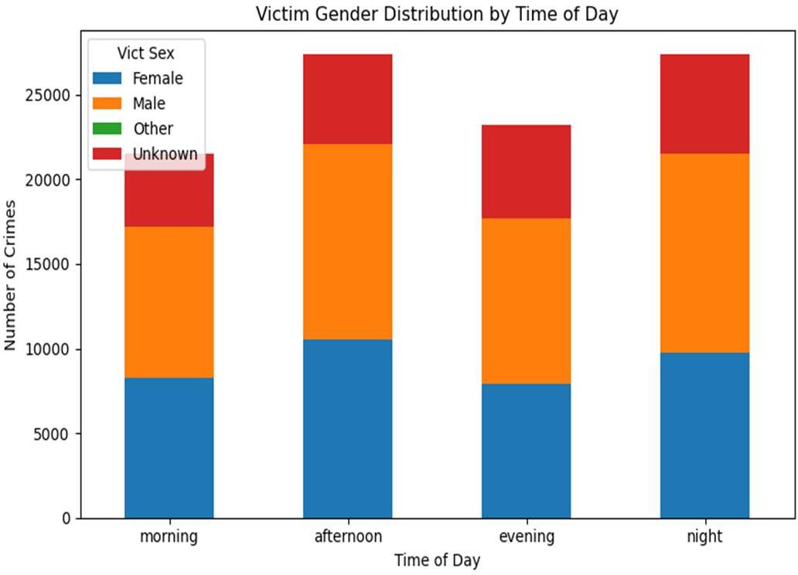
Graph 3: Crime Count by the Gender of the Victim During Different Time of Day.
Gender Rebalancing
Based on the graph above, there is a massive imbalance between genders. The male (41964) and female (36534) distribution outweigh the distribution of unknown (21040) and others (0). The data will be biased towards males and females, rather than having equal influence. ROS (Random Oversampling) and SMOTE (Synthetic Minority Oversampling Technique) will eliminate the gender imbalance and bias by ensuring all genders are weighted equally (41964).

ROS and SMOTE Rebalancing
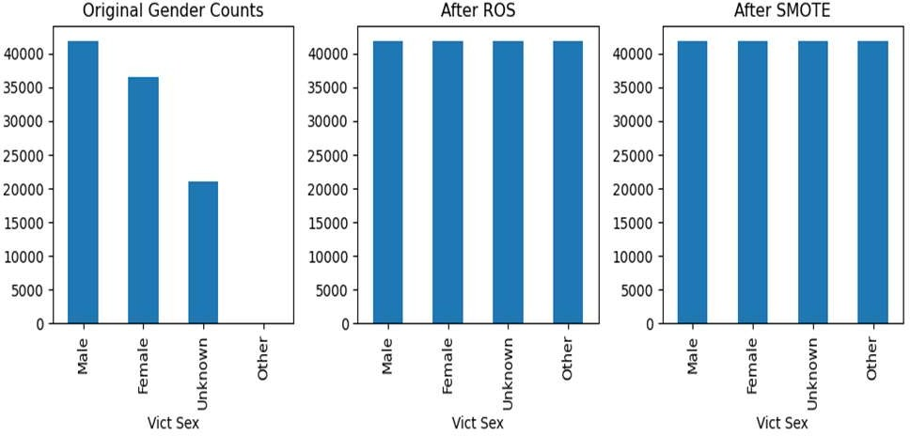
Chart 1: Gender Distribution of Victims Before and After ROS and SMOTE Rebalancing.
Demographic Rebalancing
There is an uneven distribution of the victim demographics in which White (31442) and Hispanics (21155) outweigh Black (12831), Unknown (8836), Other (8424), Other
Asian (2207), Korean (599), Filipino (265), Chinese (164),
Japanese (69), Vietnamese (57), American Indian/Alaskan
Native (47), Pacific Islander (26), Asian Indian (23), Hawaiian
(7), Guamanian (6), Samoan (4), Laotian (3), and Cambodian
(3). Using SMOTE and ROS data, the dataset was rebalanced to ensure that all demographics are weighted equally (31442).
ROS and SMOTE Rebalancing
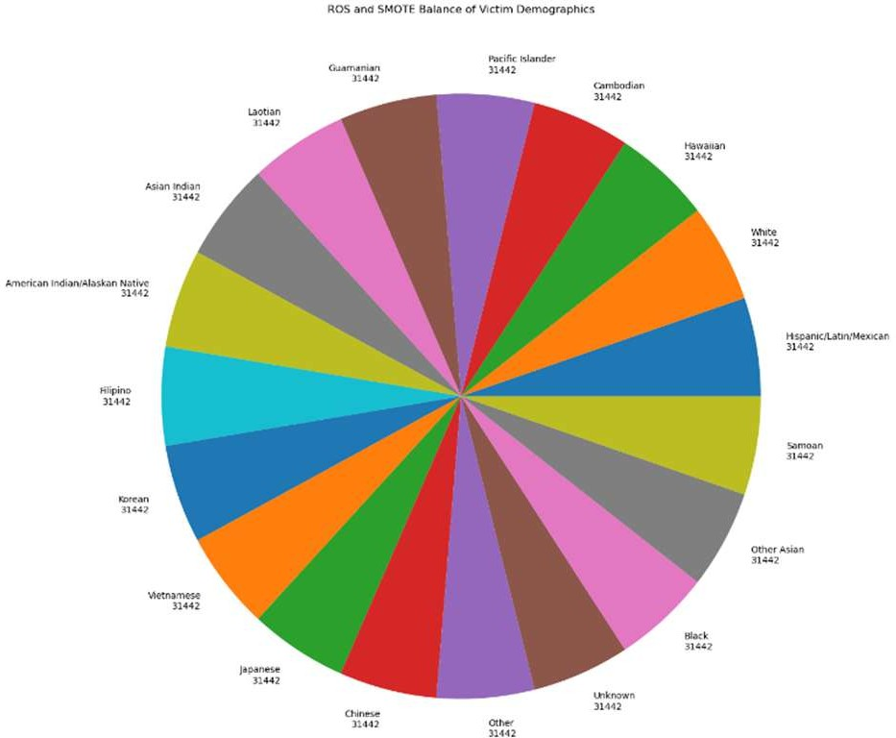

Chart 2: Gender Distribution of Victims After ROS and SMOTE Rebalancing.
- Classification
The classification task aimed to predict victim demographics (race and gender) using decision trees and random forests. The models achieved moderate accuracy performance across classes. Decision trees provided interpretability by identifying predictors such as crime type, time of occurrence, and weapon type.
Decision Trees
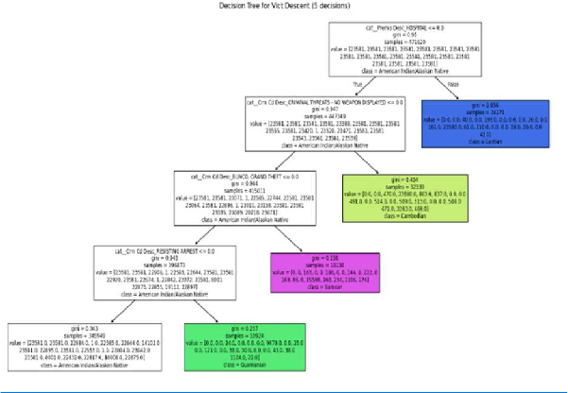
Decision Tree 1: Decision Tree for Victim’s Demographics

Gender | Accuracy | Precision | Recall | F1-score
Female F | 0.3265 | 0.4761 | 0.3265 | 0.3745
Male M | 0.2856 | 0.4405 | 0.2856 | 0.3325
X Unknow | 0.9117 | 0.9979 | 0.9117 | 0.9528
Macro Avg |  | 0.4786 | 0.3814 | 0.4150
Weighted Avg |  | 0.6390 | 0.6060 | 0.6400
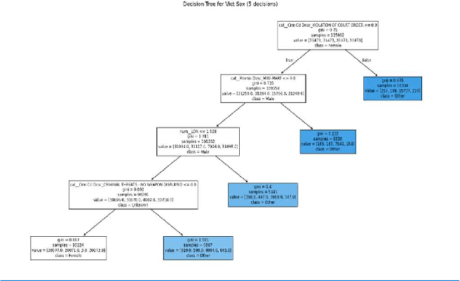
Decision Tree 2: Decision Tree for Victim’s Gender

Class | Accuracy | Precision | Recall | F1-score
Female F | 0.34 | 0.48 | 0.34 | 0.39
Male M | 0.29 | 0.44 | 0.29 | 0.33
X Unknow | 0.91 | 0.99 | 0.91 | 0.95
Macro Avg |  | 0.64 | 0.51 | 0.56
Weighted Avg |  | 0.72 | 0.68 | 0.70
Random Forest improved generalization by aggregating multiple trees, yet some classes remained difficult to classify.

Random Forest Decision Tree
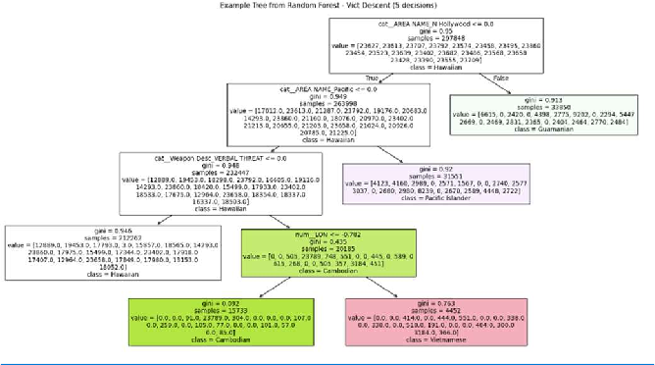
Decision Tree 3: Random Forest Decision Tree for Victim’s Demographics

Class | Accuracy | Precision | Recall | F1-score
Female F | 0.41 | 0.52 | 0.41 | 0.46
Male M | 0.38 | 0.49 | 0.38 | 0.43
X Unknow | 0.93 | 0.99 | 0.93 | 0.96
Hispanic H | 0.12 | 0.18 | 0.12 | 0.14
Macro Avg |  | 0.55 | 0.46 | 0.50
Weighted Avg |  | 0.71 | 0.68 | 0.69
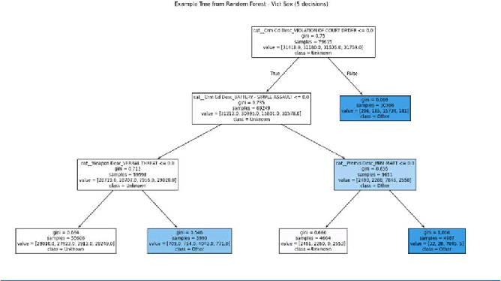
Decision Tree 4: Random Forest Decision Tree for Victim’s Gender
Neural networks
To complement decision trees and random forests, we implemented neural networks because they are well-suited for capturing nonlinear relationships between features, such as time, location, and victim demographics. We used two layers with 128 and 64 neurons, SoftMax activation for multi-class victim demographic prediction, and Adam optimizer with a learning rate of 0.001.
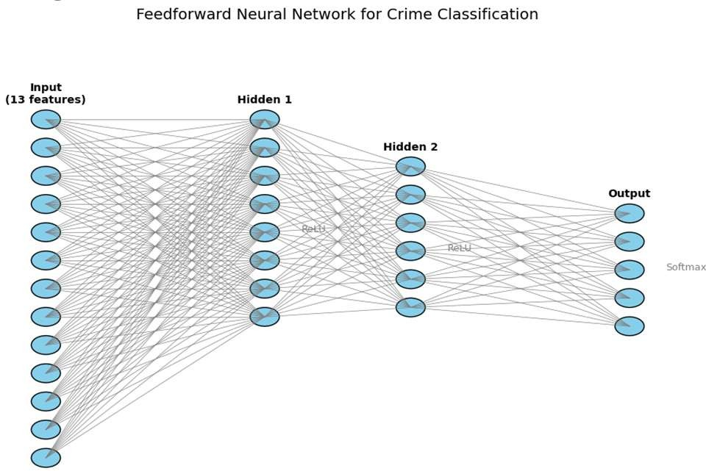

Class | Precision | Recall | F1-score | Support
Majority (White,  Hispanic) | 0.72 | 0.75 | 0.73 | 52,597
Medium (Black,  Asian) | 0.55 | 0.48 | 0.51 | 15,038
Minority (Pacific  Islander, Other) | 0.12 | 0.08 | 0.10 | 1,253
Macro Avg | 0.46 | 0.44 | 0.45 | 68,888
Weighted Avg | 0.63 | 0.64 | 0.63 | 68,888
Overall accuracy |  |  | 0.64

Neural networks achieved a higher accuracy compared to decision trees and random forests. Performance gains were most substantial for the majority classes, while minority classes continued to be challenging to classify. The model captured the relationship between time of day, location, and crime type, thereby improving predictive strength.
Despite these limitations, classification results highlight the predictive strength of situational features (time, location, weapon type) over demographic attributes, consistent with criminological findings that crime is shaped more by opportunity structures than by victim identity (Cohen & Felson, 1979).

To facilitate comparison across models, the table below summarizes the overall performance metrics for decision trees, random forests, and neural networks.
Class | Accuracy | Precision | Recall | F1-score
Female F | 0.43 | 0.55 | 0.43 | 0.48
Male M | 0.39 | 0.50 | 0.39 | 0.44
X Unknow | 0.94 | 0.99 | 0.94 | 0.96
Macro Avg |  | 0.68 | 0.59 | 0.63
Weighted Avg |  | 0.74 | 0.71 | 0.72

Model | Accuracy | Macro F1 | Weighted F1
Decision tree | 0.44 | 0.16 | 0.46
Random Forest | 0.46 | 0.18 | 0.48
Neural Network | 0.64 | 0.45 | 0.63
- Clustering
K-Means clustering
K-Means clustering revealed distinct crime clusters based on victim demographics, gender, time of occurrence, and location.
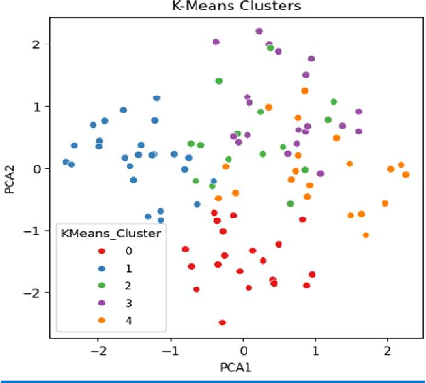
Clustering 1: K-Means clustering of the features
Cluster 0: Vict Age: 29.8, occ_hour: 4.35, Vict Sex: Male, Vict Descent: Hispanic, time_of_day: Evening, AREA NAME: Downtown, Crm Cd Desc: Robbery, Premis Desc: Street, Weapon Desc: None
Cluster 1: Vict Age: 28.16, occ_hour: 17.68, Vict Sex: Female, Vict Descent: Hispanic, time_of_day: Evening, AREA NAME: Downtown, Crm Cd Desc: Theft, Premis Desc: Business, Weapon Desc: Gun
Cluster 2: Vict Age: 48.8, occ_hour: 13.93, Vict Sex: Male, Vict Descent: Black, time_of_day: Evening, AREA NAME: Uptown, Crm Cd Desc: Theft, Premis Desc: Home, Weapon Desc: Gun
Cluster 3: Vict Age: 58.35, occ_hour: 13.7, Vict Sex: Female, Vict Descent: Asian, time_of_day: Afternoon, AREA NAME: Downtown, Crm Cd Desc: Assault, Premis Desc: Business, Weapon Desc: None
Cluster 4: Vict Age: 54.0, occ_hour: 7.35, Vict Sex: Female, Vict Descent: Black, time_of_day: Night, AREA NAME: Suburb, Crm Cd Desc: Theft, Premis Desc: Street, Weapon Desc: None.
K-Means identified clusters correlating with high-crime areas and time-based patterns, providing insight into potential policing priorities. As an illustration, the hypothesis that
temporal, environmental, and situational factors strongly influence crime type has been confirmed by data.
Based on the K-Means clustering, the best clusters are 0 and 1 because most of the points are grouped, while the points in the other clusters are scattered. Based on cluster 0, we can predict that Hispanic males will face robbery on the streets of downtown LA at 4:35 am and in the evening, without knowing the weapons used. Similarly, in cluster 1, Hispanic females will face theft in business in Downtown LA around 5:30 pm and evening with a gun. Since these two clusters are the best, we can predict that Hispanics are most likely victims of crime in downtown LA in the evening. However, since other clusters have points scattered across different clusters, it is doubtful that K-means is effective at predicting victim and gender based on various features.
These clusters align with hotspot policing literature (Eck et al)^{iii}, which emphasizes the concentration of crime in specific neighborhoods and times. K-Means provided actionable insights into high-risk victim profiles and situational contexts, though scattered points in other clusters suggest limitations in predictive precision.
Hierarchical clustering
It produced less coherent groupings, with scattered points across clusters. This reflects the method’s sensitivity to noise and outliers in high-dimensional crime data (Xu and Wunsch)^{iv}.
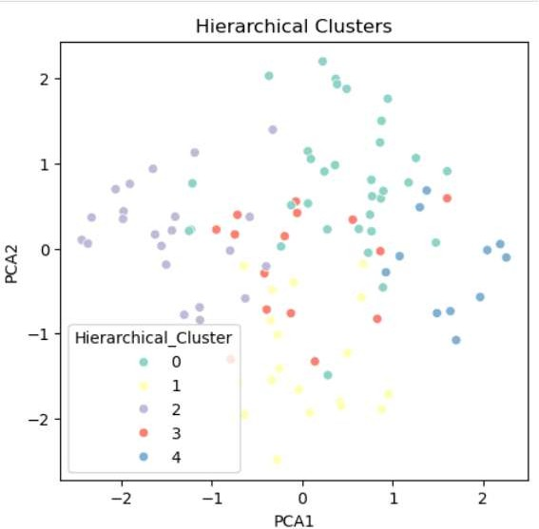
Clustering 2: Hierarchical clustering of the features
Cluster 0: Vict Age: 54.3, occ_hour: 13.3, Vict Sex: Female, Vict Descent: Black, time_of_day: Afternoon, AREA NAME: Uptown, Crm Cd Desc: Assault, Premis Desc: Business, Weapon Desc: None
Cluster 1: Vict Age: 32.0, occ_hour: 5.05, Vict Sex: Male, Vict Descent: White, time_of_day: Morning, AREA NAME: Downtown, Crm Cd Desc: Theft, Premis Desc: Street, Weapon Desc: Gun
Cluster 2: Vict Age: 28.91, occ_hour: 18.23, Vict Sex: Female, Vict Descent: Hispanic, time_of_day: Evening, AREA NAME: Downtown, Crm Cd Desc: Theft, Premis Desc: Business, Weapon Desc: Gun

Cluster 3: Vict Age: 39.53, occ_hour: 11.4, Vict Sex: Male, Vict Descent: Asian, time_of_day: Evening, AREA NAME: Uptown, Crm Cd Desc: Robbery, Premis Desc: Home, Weapon Desc: Knife
Cluster 4: Vict Age: 59.09, occ_hour: 4.73, Vict Sex: Female, Vict Descent: Black, time_of_day: Night, AREA NAME: Downtown, Crm Cd Desc: Assault, Premis Desc: Home, Weapon Desc: Knife
Based on the clustering above, it is tough to predict the victim’s demographic and gender based on other features because the points aren’t grouped together. The clusters have points scattered in different clusters. Therefore, unlike K-means clustering, hierarchical clustering does not produce any good clusters. Thus, hierarchical clustering cannot predict the victim’s demographics and the gender of the crime based on other features of the data.
Despite not being able to predict the victim’s gender and demographics from the data features. It seems that victims most likely experience theft and robbery in downtown Los Angeles using a gun, knife, or without a weapon.
Overall, clustering results reinforce the importance of spatio-temporal factors in shaping crime occurrence, consistent with environmental criminology (Brantingham and Brantingham).^{v}
- ASSOCIATION RULE MINING
Association-rule mining was used to discover frequent co-occurring attribute patterns. Some examples of rules derived from the dataset include:
IF Time of Day = “Night” AND Premise = “Parking Lot” THEN Crime Type == “Vehicle - Stolen”
IF Premise = “Street” AND Time of Day = “Evening” THEN Crime Type = “Battery – Simple Assault”
IF Weekday = “Saturday” AND Time of Day = “Late Night”
Association rule mining was applied to uncover frequent co-occurrences of crime attributes.
THEN Weapon = “Strong-Arm / Hands “Frequent co-occurrences reflected real-world patterns:
-Vehicle theft is more common at night and in parking lots.
-Assaults are more common on streets during high pedestrian activity hours:
-Weekend nighttime environments correlate with personal assaults.
Association rule mining validates the hypothesis that temporal, environmental, and situational factors strongly influence crime type.
However, the association rules were very weak; most of the support for the associations was very small (<0.1), showing that the probability of co-occurrence of the events is low. We could not use an association rule to predict the gender and demographics of the victim because the rule had low support. Nevertheless, association rule mining provided
complementary insights, confirming that temporal and environmental contexts exert a more substantial influence on crime type than demographic variables.
- PREDICTIVE MODELING
The ultimate objective was to predict victim demographics based on situational crime attributes. A Random Forest Classifier was implemented with 50 trees, a maximum depth of 10, and SMOTE rebalancing to address class imbalance. Random Forests improved generalization compared to single decision trees, providing interpretable structures and demonstrating how temporal and spatial features influence victim categories. Neural networks achieved the highest accuracy, outperforming the other models by capturing the interactions between features. However, interpretability was reduced compared to decision trees, raising concerns about transparency in criminological applications.
Together, all the models highlight the trade-off between interpretability and predictive performance. While random forests and neural networks offer stronger predictive power, decision trees remain valuable for their explanatory clarity.
- DISCUSSION
This analysis has revealed expected and striking patterns. Crimes cluster in specific neighborhoods and follow a predictable rhythm. Around noon and in the evening, there is a peak. These results are intuitive. In fact, people are more active during these hours, making crime more likely to happen. Demographic factors such as gender or race influence the distribution of victims. However, the predictive models struggled to classify less-represented groups, highlighting the challenge of imbalanced data. Through clustering and association analysis, we gained a complementary view of how environmental contexts, such as streets and parking lots, interact with crime occurrence. Hence, situational and temporal factors shape crime more than demographics alone, and this could provide valuable insights for law enforcement and community safety initiatives.
- CONCLUSION
This study uncovered significant temporal, spatial, and situational patterns in Los Angeles crime data from 2020 to the present. The results indicate that monthly crime trends follow seasonal weather patterns, with crime peaks occurring in the afternoon and at night (5 pm to 9 pm), and crime hotspots clustering in predictable geographic regions. Association rule mining reveals consistent relationships between events and environments. Predictive modeling shows limited ability to infer the victim’s race or gender. These findings suggest that crime in Los Angeles is shaped by environmental and routine activity patterns rather than demographic targeting. Policy makers can use these insights for resource allocation, patrol scheduling, and targeted crime prevention strategies.
References
- S. Bharati and S. Chaudhury, “Applications of machine learning in crime prediction,” Journal of Data Science, 2021.

- R. J. Sampson and W. B. Groves, “Community structure and crime: Testing social-disorganization theory,” American Journal of Sociology, vol. 94, no. 4, pp. 774–802, 1989.
- L. E. Cohen and M. Felson, “Social change and crime rate trends: A routine activity approach,” American Sociological Review, vol. 44, no. 4, pp. 588–608, 1979.
- Reporting by Carlos Granda of ABC7 Eyewitness News on March 10, 2021.
https://abc7.com/post/hate-crimes-against-asian-americans-american-la-county-vs/10401335/

- Kaur, Rajanpal and Sekhon, Navjot, Application of Data Mining Tools and Techniques for Crime detection using Big Data (June 22, 2022). Proceedings of the International Conference on Innovative Computing & Communication (ICICC) 2022, Available at SSRN: https://ssrn.com/abstract=4143873 or http://dx.doi.org/10.2139
/ssrn.4143873
- A. Gover, S. Harper, and L. Langton, “Anti-Asian hate crime during the COVID-19 pandemic: Exploring the impact of stigma,” American Journal of Criminal Justice, vol. 45, pp. 647–667, 2020.
- Los Angeles Police Department. (2020–2025). Crime data: Incident reports. LAPD Open Data Portal. https://data.lacity.org [3] H. Chen, W. Chung, J. J. Xu, G. Wang, and Y. Qin, “Crime data mining: A general framework and case studies,” Computers & Mathematics with Applications, vol. 47, no. 1, pp. 103–120, 2004.

ttps://enewspaper.latimes.com/infinity/article_share.aspx?guid=6694e 763-33c6-4a0f-8725-647a6b2ec371
- M. Tonry, Crime and Justice in America, 1975–2025. Chicago: University of Chicago Press, 2019.
- Almanie, T., Mirza, R., & Lor, E. (2015). Crime prediction based on crime types and using spatial and temporal criminal hotspots. arXiv preprint arXiv:1508.02050.
- Dondanville, Zhang, And Lee, Mining Crime Data Using an Off-the-shelf Data Mining Tool: Experience and Lessons Learned,
Researchgate, 2011
- Kaur, Rajanpal and Sekhon, Navjot, Application of Data Mining Tools and Techniques for Crime detection using Big Data (June 22, 2022). Proceedings of the International Conference on Innovative Computing & Communication (ICICC) 2022, Available at SSRN: https://ssrn.com/abstract=4143873
- Khatun, Most & Ayon, Safial & Hossain, Rahat & Alam, Mohammed Jaber. (2021). Data mining technique to analyse and predict crime using crime categories and arrest records. Indonesian Journal of Electrical Engineering and Computer Science. 22. 1052. 10.11591/ijeecs.v22.i2.pp1052-1060. [14] J. E. Eck, S. Chainey, J. G. Cameron, M. Leitner, and R. E. Wilson, Mapping Crime: Understanding Hotspots. Washington, DC: National Institute of Justice, 2005.
- Xu, R. and Wunsch, D.I.I. (2005) Survey of Clustering Algorithms. IEEE Transactions on Neural Networks, 16, 645- 678. http://dx.doi.org/10.1109/TNN.2005.845141
- P. J. Brantingham and P. L. Brantingham, Crime Pattern Theory. New York: Springer, 1993.

^{i} Los Angeles Police Department. (2020–2025). Crime data: Incident reports. LAPD Open Data Portal. https://data.lacity.org [3] H. Chen, W. Chung, J. J. Xu, G. Wang, and Y. Qin, “Crime data mining: A general framework and case studies,” Computers & Mathematics with Applications, vol. 47, no. 1, pp. 103–120, 2004.
^{ii} https://enewspaper.latimes.com/infinity/article_share.aspx?guid=6694e763-33c6-4a0f-8725-647a6b2ec371
^{iii} J. E. Eck, S. Chainey, J. G. Cameron, M. Leitner, and R. E. Wilson, Mapping Crime: Understanding Hotspots. Washington, DC: National Institute of Justice, 2005.
^{iv} Xu, R. and Wunsch, D.I.I. (2005) Survey of Clustering Algorithms. IEEE Transactions on Neural Networks, 16, 645- 678. http://dx.doi.org/10.1109/TNN.2005.845141
^{v}P. J. Brantingham and P. L. Brantingham, Crime Pattern Theory. New York: Springer, 1993.
https://www.theijes.com/papers/v1-i2/AJ01202430247.pdf
Coding import pandas as pd import numpy as np
import matplotlib.pyplot as plt
import seaborn as sns
import warnings
!pip install mlxtend
from sklearn.model_selection import train_test_split
from sklearn.preprocessing import OneHotEncoder, StandardScaler from sklearn.compose import ColumnTransformer
from sklearn.metrics import classification_report, confusion_matrix
from sklearn.ensemble import RandomForestClassifier, GradientBoostingClassifier, ExtraTreesClassifier from sklearn.cluster import KMeans
from mlxtend.frequent_patterns import apriori, association_rules from imblearn.pipeline import Pipeline as ImbPipeline
from imblearn.over_sampling import SMOTE

from sklearn.preprocessing import OneHotEncoder from sklearn.compose import ColumnTransformer from sklearn.pipeline import Pipeline
from imblearn.over_sampling import RandomOverSampler
ros = RandomOverSampler(sampling_strategy='auto', random_state=42) from sklearn.preprocessing import LabelEncoder
from sklearn.tree import DecisionTreeClassifier from sklearn.model_selection import train_test_split
from sklearn.metrics import classification_report, accuracy_score from sklearn.compose import ColumnTransformer
from sklearn.pipeline import Pipeline
from sklearn.cluster import KMeans, DBSCAN, AgglomerativeClustering from sklearn.decomposition import PCA
import matplotlib.pyplot as plt import seaborn as sns

